**Experiment No. 1.1**

**Student Name: Rishav Kumar UID: 22MCC20039**

**Branch: MCA - CCD Section/Group: MCD-1/ Grp A**

**Semester: II Date of Performance: 10th Aug 23**

**Subject Name: Business Analytics Subject Code: 22CAH-703**

1. **Aim/Overview of the practical:**

a) Formatting the worksheet using logical formula IF Statement, Nested IF, AND, OR, NOT, IFERROR, SUMIF, AVERAGEIF, COUNTIF and AVERAGEIF)

b) Create and apply formulas as per user requirements.

1. **Code for practical:**

* Performing following formula for following table.

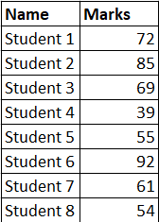

* **IF Statement:** To check if marks are greater than 50 for, then print PASS else FAIL.

*=IF(D5>50, "PASS", "FAIL")*

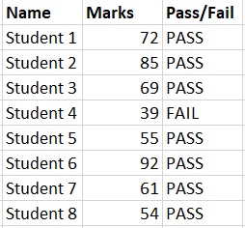

* **NESTED IF:** To enter grades, we use nested if to provide grades.

*=IF(AND(D6>=80, D6<=100), "Distinction", IF(AND(D6>=60, D6<=79), "Passed", "FAIL"))*

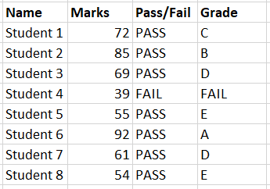

* **AND:** If marks are greater than equal 80 and less than equal to 100, print Distinction, if marks are greater than equal to 60 and less than equal to 79.

*=IF(AND(D6>=80, D6<=100), "Distinction", IF(AND(D6>=60, D6<=79), "Passed", "FAIL"))*

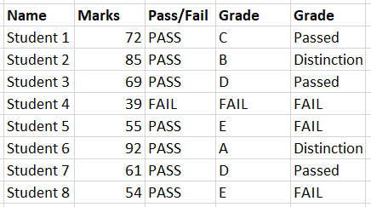

* **OR:** If marks are greater than equal 80, print Distinction, if marks are greater than equal to 60 or less than equal to 79.

*=IF(OR(D5>=80), "Distinction", IF(OR(D5>=60, D5<=79), "Passed", "FAIL"))*

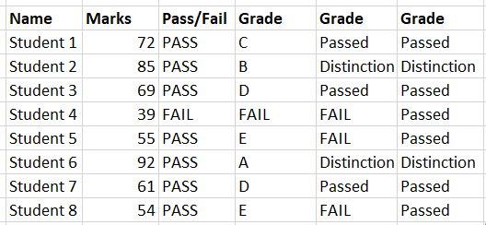

* **NOT:** Select any cell with logical value and use *=NOT(cell_name)*.
* **IF ERROR:** *=IFERROR(D9/D17, "Error")*
* **AVERAGEIF:** *=AVERAGEIF(F6:F12, "Passed", D6:D13)*
* **COUNTIF:** *=COUNTIF(D5:D12, ">=80")*

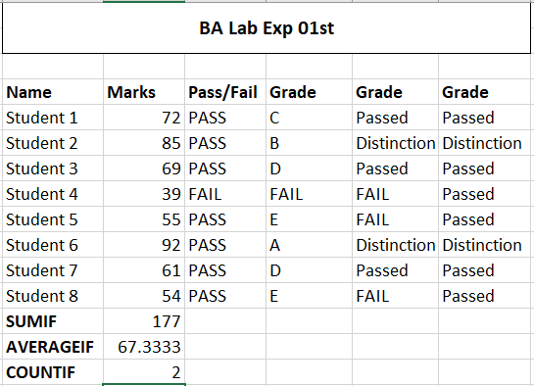

**************************************** **THE END** ***********************************************